Firm Asymmetry Telos Results

Subject pool:

218 subjects passed at least two comprehension check (out of 3)

1. **2x8 ANOVA** 
   1. There is no interaction between firm name and moral change for any mediator (including categorical)

> print(summary(aov(prediction_1_all ~ imp_det*firm.name, d))) # no interaction

Df Sum Sq Mean Sq F value Pr(>F)

imp_det 1 6341 6341 10.622 0.00168 **

firm.name 7 7056 1008 1.689 0.12468

imp_det:firm.name 7 7199 1028 1.723 0.11642

Residuals 75 44769 597

---

Signif. codes: 0 ‘***’ 0.001 ‘**’ 0.01 ‘*’ 0.05 ‘.’ 0.1 ‘ ’ 1

127 observations deleted due to missingness

> print(summary(aov(identity_1_all ~ imp_det*firm.name, d))) # some interaction

Df Sum Sq Mean Sq F value Pr(>F)

imp_det 1 5458 5458 6.920 0.00973 **

firm.name 7 9148 1307 1.657 0.12700

imp_det:firm.name 7 4365 624 0.791 0.59665

Residuals 111 87550 789

1. **T-tests (prediction vs identity as affected by moral change):** 
   1. Confirmed: We predict participants are more likely to agree that the firm’s identity has been disrupted after deteriorating than improving. Conversely, we predict that they are more likely to predict the firm will revert to its previous state after improving than deteriorating.

Welch Two Sample t-test

data: identity_1_all by imp_det

t = 2.6007, df = 124.99, p-value = 0.01043

alternative hypothesis: true difference in means is not equal to 0

95 percent confidence interval:

3.134411 23.095862

sample estimates:

mean in group det mean in group imp

50.95385 37.83871

Welch Two Sample t-test

data: prediction_1_all by imp_det

t = -3.0926, df = 88.997, p-value = 0.00265

alternative hypothesis: true difference in means is not equal to 0

95 percent confidence interval:

-27.42242 -5.96888

sample estimates:

mean in group det mean in group imp

23.00000 39.69565

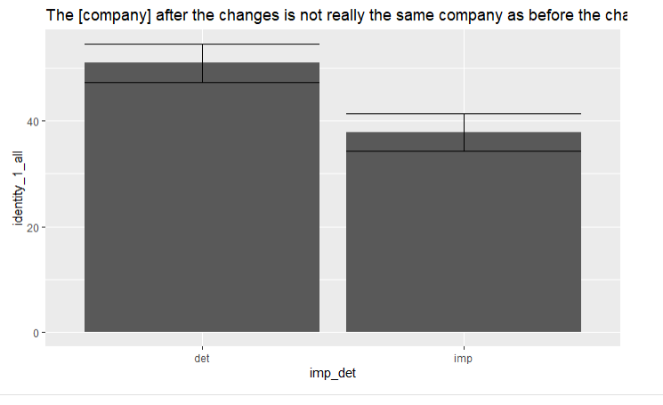

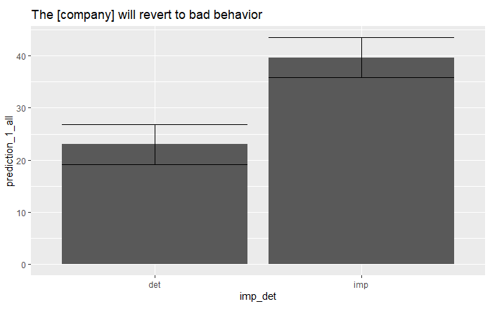

1. Mediation
   1. Identity is mediated by essentialism but not by other variables

Outcome variable: identity_1_all

Coeff BootMean BootSE BootLLCI BootULCI

constant 26.8692 27.5210 13.6696 2.8342 55.9515

imp_det -4.8380 -4.9296 4.1096 -13.2833 2.9736

**essentialism 0.6229 0.6221 0.0876 0.4455 0.7890**

telos 0.0675 0.0701 0.1131 -0.1547 0.2897

categorical -0.0764 -0.0842 0.0990 -0.2958 0.0884

* 1. Prediction is mediated by categorical?

Outcome variable: prediction_1_all

Coeff BootMean BootSE BootLLCI BootULCI

constant 30.9065 31.2361 21.4748 -10.7978 72.7989

imp_det 14.4952 14.6434 5.9632 3.0579 26.3604

essentialism 0.1007 0.1026 0.1010 -0.0869 0.3110

telos 0.0203 0.0232 0.1559 -0.2969 0.3261

**categorical -0.3081 -0.3173 0.1484 -0.6256 -0.0528**

1. Psychopathic Ascriptions moderating predictions. No significance in any kind of psychopathic ascriptions for prediction.

Call:

lm(formula = prediction_1_all ~ psychopathy, data = subset(d,

imp_det == "imp"))

Residuals:

Min 1Q Median 3Q Max

-40.722 -20.170 -0.389 18.319 47.488

Coefficients:

Estimate Std. Error t value Pr(>|t|)

(Intercept) 35.2258 13.5163 2.606 0.0124 *

psychopathy 0.0772 0.2237 0.345 0.7317

---

Signif. codes: 0 ‘***’ 0.001 ‘**’ 0.01 ‘*’ 0.05 ‘.’ 0.1 ‘ ’ 1

Residual standard error: 26.22 on 44 degrees of freedom

(62 observations deleted due to missingness)

Multiple R-squared: 0.0027, Adjusted R-squared: -0.01997

F-statistic: 0.1191 on 1 and 44 DF, p-value: 0.7317

Call:

lm(formula = prediction_1_all ~ psychopathy, data = subset(d,

imp_det == "det"))

Residuals:

Min 1Q Median 3Q Max

-23.805 -22.443 -8.455 14.238 77.343

Coefficients:

Estimate Std. Error t value Pr(>|t|)

(Intercept) 24.70544 15.59609 1.584 0.121

psychopathy -0.02649 0.23473 -0.113 0.911

Residual standard error: 25.83 on 43 degrees of freedom

(65 observations deleted due to missingness)

Multiple R-squared: 0.000296, Adjusted R-squared: -0.02295

F-statistic: 0.01273 on 1 and 43 DF, p-value: 0.9107